DE–7677
11
DISTANCE EDUCATION
M.Phil. (Mathematics) DEGREE EXAMINATION, DECEMBER 2009.
COMMUTATIVE ALGEBRA
(Upto 2006 Batch)
Time : Three hours Maximum : 100 marks
Answer any FIVE questions.
- (a) Let R be a local ring. Prove that any finitely generated projective R-module is free.
(b) Prove that the nil radical of R is the intersection of all prime ideals of R.
- State and prove Chinese Remainder theorem.
- (a) Prove that for any ideal I of R, the radical is the intersection of all prime ideals containing I.
(b) Prove that the ideal I and J are co maximal if and only if their radicals are co maximal.
- (a) Prove that R is a local ring if and only if it has a unique maximal ideal.
(b) Prove that a primary ideal need not be a power of a prime ideal.
- (a) Prove that if R is a Noetherian ring so is R [x].
(b) Prove that in an Artinian ring every nil radical is nil potent.
- State and prove first uniqueness’ theorem on primary decomposition.
- Prove that an Artinian ring is uniquely isomorphic to a finite direct product of Artinian local rings.
- Prove the following.
(a) Every discrete Valuation ring is Noetherian.
(b) Every discrete Valuation ring is a local ring.
(c) Any non zero ideal is a power of the maximal ideal.
———————
DE–7678
12
DISTANCE EDUCATION
M.Phil. (Maths) DEGREE EXAMINATION, DECEMBER 2009.
MEASURE THEORY
(Upto 2006 Batch)
Time : Three hours Maximum : 100 marks
Answer any FIVE questions.
Each question carries 20 marks.
- (a) If and are real measurable functions on a measurable space and is a continuous mapping of the plane into a topological space , prove that the function 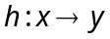 given by 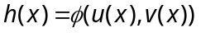 is
measurable.
(b) State and prove Fatou’s lemma.
- (a) State and prove Lebesgue’s monotone convergence
theorem.
(b) If 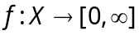 is measurable and 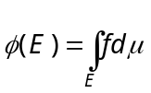 where 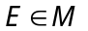 , prove that is a measurable on M
and 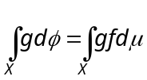 .
- State and prove Riesz Representation theorem.
- Let  be a locally compact Hausdorff space in which every openset is . Compact. If is a positive Borel measure on such that 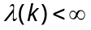 for every compact
set , prove that is regular.
- (a) Define convex function and prove that any convex function on (a, b) is continuous.
(b) State and prove Jensen’s inequality.
- State and prove the Hahn Decomposition theorem.
- If 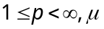 is a – finite positive measure on X and is a bounded linear functional on 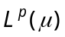 then prove that there is a unique 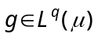 where is the exponent conjugate to such that 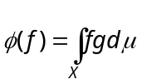.
- Let 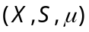 and 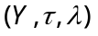 be a – finite measure spaces and 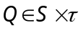. If 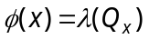 and 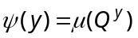 for every
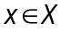 and , Prove that is S – measurable and 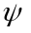 is – measurable and 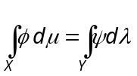.

————————
DE–7679
13
DISTANCE EDUCATION
M.Phil. (Mathematics) DEGREE EXAMINATION, DECEMBER 2009.
TOPOLOGICAL VECTOR SPACES
(Upto 2006 Batch)
Time : Three hours Maximum : 100 marks
Answer any FIVE questions.
(5 × 20 = 100)
- (a) Show that if B is a local base for a topological vector space X then every member of B contains the closure of same member of B.
(b) Show that every locally compact topological vector space X has finite dimension.
- (a) Show that if 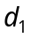 and 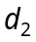 are invariant metrices on a vector space X which induce the same topology on X then
(i) , have the some Cauchy sequence.
(ii) is complete if and only if is complete.
(b) Show that the following are equivalent on a topological vector space E.
(i) E is bounded
(ii) If 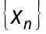 is a sequence in E and {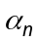} is a sequence of scalars such that 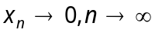 then 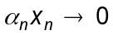 as .
- (a) State and prove Banach-Steinhans theorem.
(b) Show that if 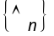 is a sequence of continuous linear mapping from on F-space X into a topological vector space Y and if 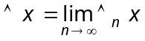 exists for every 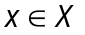 then is continuous.
- State and prove the open mapping theorem.
- (a) State and prove Hahn-Banach separation theorem.
(b) Show that if f is a continuous linear functional on a subspace M of a locally convex space X then there exists 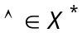 such that 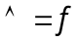 on M.
- State and prove that Banach – Alaoglu theorem.
- (a) Suppose X is a topological vector space with 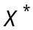 separate points show that if K is a compact convex set in X then K is the closed convex hull of the set of its extreme points.
(b) Suppose H is the convex hull of a compact set K in a topological space X. Show that if X is a Frechet space then H is compact.
- (a) Suppose X, Y are Banach spaces. Show that
(i) 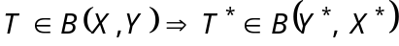 that satisfies 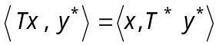 for all 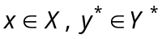.
(ii) 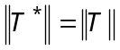.
(b) Suppose X, Y are Banach spaces and 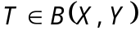. Show that T is compact if and only if 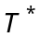 is compact.
———————
DE-7680
14 A
DISTANCE EDUCATION
M.Phil. (Mathematics) DEGREE EXAMINATION, DECEMBER 2009.
FUNDAMENTALS OF DOMINATIONS IN GRAPHS
(Upto 2006 batch)
Time : Three hours Maximum : 100 marks
Answer any FIVE questions.
All questions carry equal marks.
- (a) Prove that if G is a graph without isolated vertices and if S is a minimal dominating set of G then V-S is a dominating set S.
(b) Show that if a graph has no isolated vertices then 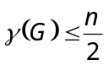.
- State and prove a necessary and sufficient condition for a tree to be a wounded spider.
- Prove that if 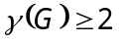 then 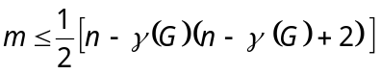.
- If 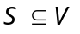 is a maximal irredundant set in a graph 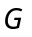, prove that it is a minimal external redundant set.
- If 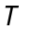 is a tree of order 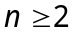, prove that 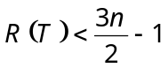 and 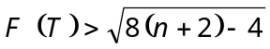.
- Prove that if has no isolated vertices then
Dir 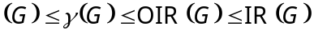.
- Prove that a vertex V is in 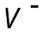 if and only if 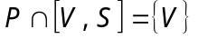 for some set containing .
- Prove that a graph 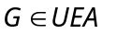 iff V is empty.
———————
DE–7681
14 B
DISTANCE EDUCATION
M.Phil. (Maths) DEGREE EXAMINATION, DECEMBER 2009.
DATA STRUCTURE AND ALGORITHMS
(Upto 2006 Batch)
Time : Three hours Maximum : 100 marks
Answer any FIVE questions.
All questions carry equal marks.
- (a) Compare friend function with inline function.
(b) Discuss :
(i) Dynamic object
(ii) Default constructor.
- (a) How to estimate and reduce the running time of a program?
(b) What is list? Explain the cursor implementation in linked list.
- (a) Discuss the merits and demerits of representing a data sequentially and non-sequentially.
(b) Write a program to add two polynomial have M and N terms, represented by a linked list, and calculate the time complexity of program?
- (a) What is stack? Explain the array implementation of stack.
(b) Write a program to evaluate a postfix expression.
- (a) How to construct an expansion tree?
(b) Write a program to construct a tree and to compute the depth and height of a tree.
- (a) Write a program to check if two trees are isomorphic or not.
(b) Write efficient functions that take only a pointer to the root of a binary tree, T, and compute? The number of nodes in T.
- (a) What is Graph? Write a program to find the shortest weighted path from S to every other vertex in G, Where G is a weighted Graph G = (V,E) given as input to a program.
(b) Define Graph, Write a program to traverse the graph.
- Write and analyze prim's and kruskal algorithms.
————————

